

Practical No.: 9
Aim –
Implement localStorage and sessionStorage to save user preferences like theme settings.
Software/Tools Required –
- VSCode
- Chrome
- HTML5
- CSS3
- Javascript (ES6)
Experiment Program Code –
index.html
<!DOCTYPE html>
<html lang="en">
<head>
<meta charset="UTF-8" />
<meta name="viewport" content="width=device-width, initial-scale=1.0" />
<title>Theme Preferences</title>

<style>
* {
box-sizing: border-box;
}

body {
margin: 0;
min-height: 100vh;
display: flex;
align-items: center;
justify-content: center;
font-family: Arial, sans-serif;

background:
radial-gradient(circle at 15% 20%, #c7d2fe 0%, transparent 30%),
radial-gradient(circle at 85% 80%, #fbcfe8 0%, transparent 30%),
linear-gradient(135deg, #eef2ff, #f8fafc);

color: #1e293b;
transition: all 0.5s ease;
overflow: hidden;
}

body::before,
body::after {
content: "";
position: fixed;
border-radius: 50%;
filter: blur(2px);
z-index: -1;
}

body::before {
width: 220px;
height: 220px;
background: rgba(129, 140, 248, 0.25);
top: -70px;
left: -70px;
}

body::after {
width: 260px;
height: 260px;
background: rgba(244, 114, 182, 0.2);
bottom: -100px;
right: -80px;
}

.container {
width: 90%;
max-width: 570px;
padding: 50px 45px;

text-align: center;

background: rgba(255, 255, 255, 0.72);
backdrop-filter: blur(18px);
-webkit-backdrop-filter: blur(18px);

border: 1px solid rgba(255, 255, 255, 0.7);
border-radius: 28px;

box-shadow:
0 25px 60px rgba(30, 41, 59, 0.15),
inset 0 1px 0 rgba(255, 255, 255, 0.8);

transition: 0.5s ease;
}

.icon {
width: 82px;
height: 82px;

margin: 0 auto 22px;

display: flex;
align-items: center;
justify-content: center;

font-size: 38px;

border-radius: 24px;

background: linear-gradient(
135deg,
#6366f1,
#8b5cf6,
#ec4899
);

box-shadow:
0 12px 30px rgba(99, 102, 241, 0.35);

animation: float 3s ease-in-out infinite;
}

@keyframes float {
0%, 100% {
transform: translateY(0);
}

50% {
transform: translateY(-6px);
}
}

h1 {
margin: 0;

font-size: 32px;
font-weight: 700;

background: linear-gradient(
90deg,
#4f46e5,
#7c3aed,
#db2777
);

-webkit-background-clip: text;
-webkit-text-fill-color: transparent;
}

.subtitle {
margin: 14px auto 34px;

max-width: 430px;

color: #64748b;
font-size: 15px;
line-height: 1.7;
}

.options {
display: flex;
flex-direction: column;
gap: 14px;
}

button {
width: 100%;
padding: 15px 20px;

border: none;
border-radius: 14px;

font-size: 15px;
font-weight: 600;

cursor: pointer;

display: flex;
align-items: center;
justify-content: center;
gap: 10px;

transition: all 0.25s ease;
}

button:hover {
transform: translateY(-3px);
}

button:active {
transform: scale(0.98);
}

.light-btn {
color: #3730a3;

background: linear-gradient(
135deg,
#eef2ff,
#e0e7ff
);

border: 1px solid #c7d2fe;
}

.light-btn:hover {
box-shadow: 0 10px 25px rgba(99, 102, 241, 0.18);
}

.dark-btn {
color: white;

background: linear-gradient(
135deg,
#1e293b,
#334155
);

box-shadow: 0 8px 20px rgba(15, 23, 42, 0.18);
}

.dark-btn:hover {
box-shadow: 0 12px 28px rgba(15, 23, 42, 0.28);
}

.clear-btn {
color: #be123c;

background: rgba(255, 228, 230, 0.7);

border: 1px solid #fecdd3;
}

.clear-btn:hover {
background: #ffe4e6;
box-shadow: 0 8px 20px rgba(244, 63, 94, 0.15);
}

.storage-info {
margin-top: 28px;

font-size: 12px;
color: #94a3b8;
}

.storage-info span {
font-weight: bold;
color: #6366f1;
}

body.dark {
background:
radial-gradient(circle at 15% 20%, #312e81 0%, transparent 30%),
radial-gradient(circle at 85% 80%, #701a75 0%, transparent 30%),
linear-gradient(135deg, #020617, #0f172a);

color: white;
}

body.dark .container {
background: rgba(15, 23, 42, 0.72);

border: 1px solid rgba(148, 163, 184, 0.15);

box-shadow:
0 25px 60px rgba(0, 0, 0, 0.45),
inset 0 1px 0 rgba(255, 255, 255, 0.05);
}

body.dark h1 {
background: linear-gradient(
90deg,
#818cf8,
#a78bfa,
#f472b6
);

-webkit-background-clip: text;
-webkit-text-fill-color: transparent;
}

body.dark .subtitle {
color: #cbd5e1;
}

body.dark .light-btn {
color: #e0e7ff;

background: rgba(79, 70, 229, 0.15);

border: 1px solid rgba(129, 140, 248, 0.3);
}

body.dark .dark-btn {
background: linear-gradient(
135deg,
#f8fafc,
#e2e8f0
);

color: #0f172a;
}

body.dark .clear-btn {
color: #fda4af;

background: rgba(159, 18, 57, 0.18);

border: 1px solid rgba(244, 63, 94, 0.25);
}

body.dark .storage-info {
color: #64748b;
}

body.dark .storage-info span {
color: #818cf8;
}

@media (max-width: 500px) {

.container {
padding: 38px 25px;
}

h1 {
font-size: 27px;
}

.icon {
width: 70px;
height: 70px;
font-size: 32px;
}

.subtitle {
font-size: 14px;
}
}
</style>
</head>

<body>

<div class="container">

<div class="icon">
🎨
</div>

<h1>Theme Preferences</h1>

<p class="subtitle">
Personalize your experience by choosing a theme.
Your preference will be remembered automatically.
</p>

<div class="options">

<button class="light-btn" onclick="setTheme('light')">
☀️
<span>Light Theme</span>
</button>

<button class="dark-btn" onclick="setTheme('dark')">
🌙
<span>Dark Theme</span>
</button>

<button class="clear-btn" onclick="clearPreference()">
↺
<span>Clear Preference</span>
</button>

</div>

<div class="storage-info">
Preference saved using
<span>localStorage</span> &
<span>sessionStorage</span>
</div>

</div>

<script>
function setTheme(theme) {
if (theme === 'dark') {
document.body.classList.add('dark');
} else {
document.body.classList.remove('dark');
}

localStorage.setItem('theme', theme);

sessionStorage.setItem('sessionTheme', theme);
}

function clearPreference() {
localStorage.removeItem('theme');
sessionStorage.removeItem('sessionTheme');

document.body.classList.remove('dark');
}

window.onload = function () {
var saved = localStorage.getItem('theme');

if (saved === 'dark') {
document.body.classList.add('dark');
}
};
</script>

</body>
</html>

Output –
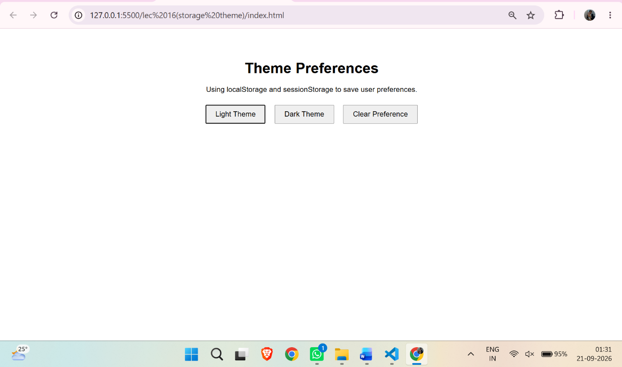
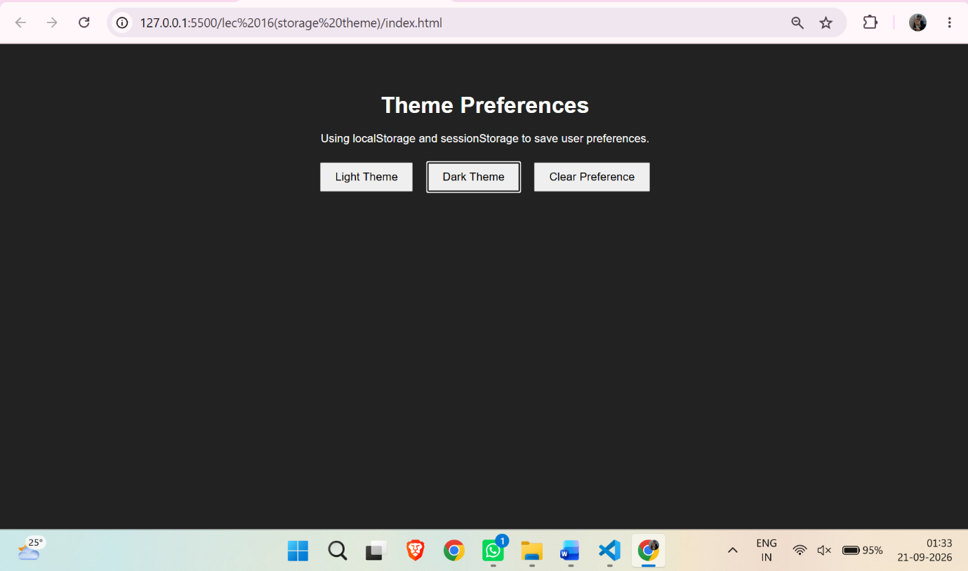
Case Study Title –
Create a Schedule Planner for the given table and show an alert box on click event.
Case Study Program Code –
index.html
<!DOCTYPE html>
<html>
<head>
<title>Seminar Schedule Planner</title>
<link rel="stylesheet" href="style.css">
</head>
<body>

<h1>Seminar Schedule Planner</h1>

<div class="form-box">
<h2>Add Schedule</h2>

<div class="form-row">
<div>
<label>Day</label>
<input type="text" id="day" placeholder="e.g. Monday">
</div>

<div>
<label>Begin Time</label>
<input type="text" id="begin" placeholder="e.g. 8:00 a.m.">
</div>

<div>
<label>End Time</label>
<input type="text" id="end" placeholder="e.g. 5:00 p.m.">
</div>

<div>
<label>Topic</label>
<input type="text" id="topic" placeholder="e.g. Introduction to XML">
</div>
</div>

<button onclick="addSchedule()">Add to Planner</button>
</div>

<p class="instruction">Click on any topic to view its details.</p>

<table>
<thead>
<tr>
<th>Day</th>
<th colspan="2">Schedule</th>
<th>Topic</th>
</tr>

<tr>
<th></th>
<th>Begin</th>
<th>End</th>
<th></th>
</tr>
</thead>

<tbody id="scheduleTable"></tbody>
</table>

<footer>
Designed By: <strong>Rudrakshi Bhandekar</strong> | PRN: <strong>24070521012</strong>
</footer>

<script src="script.js"></script>
</body>
</html>

style.css
* {
margin: 0;
padding: 0;
box-sizing: border-box;
}

body {
font-family: Arial, sans-serif;
min-height: 100vh;
background: #f4f6f8;
padding: 35px 45px 20px;
color: #222;
}

h1 {
text-align: center;
font-size: 34px;
margin-bottom: 28px;
}

.form-box {
background: white;
padding: 24px;
border-radius: 12px;
box-shadow: 0 3px 12px rgba(0, 0, 0, 0.12);
margin-bottom: 24px;
}

h2 {
font-size: 27px;
margin-bottom: 25px;
}

.form-row {
display: grid;
grid-template-columns: repeat(4, 1fr);
gap: 16px;
}

label {
display: block;
font-weight: bold;
margin-bottom: 8px;
}

input {
width: 100%;
height: 47px;
padding: 10px;
border: 1px solid #bbb;
border-radius: 6px;
font-size: 16px;
}

input:focus {
outline: none;
border-color: #2867d9;
}

button {
margin-top: 21px;
padding: 12px 25px;
border: none;
border-radius: 6px;
background: #2867d9;
color: white;
font-size: 16px;
cursor: pointer;
}

button:hover {
background: #1e55b7;
}

.instruction {
text-align: center;
margin: 20px 0 30px;
font-size: 17px;
color: #555;
}

table {
width: 95%;
margin: auto;
border-collapse: collapse;
background: white;
}

th,
td {
border: 2px solid #666;
text-align: center;
padding: 14px 10px;
font-size: 17px;
}

th {
background: #dcecf7;
font-weight: bold;
}

td:nth-child(2) {
background: #e1f2d9;
}

td:nth-child(3) {
background: #e4e8fb;
}

.topic {
background: white !important;
font-weight: bold;
color: #27558d;
cursor: pointer;
}

.topic:hover {
background: #f0f6ff !important;
}

.empty-topic {
background: white !important;
}

.edit-btn {
margin: 0;
padding: 7px 15px;
font-size: 14px;
background: #6c5ce7;
}

.edit-btn:hover {
background: #5545c7;
}

footer {
text-align: center;
margin-top: 35px;
color: #8c0385;
font-size: 18px;

}

@media (max-width: 850px) {
body {
padding: 25px 15px;
}

.form-row {
grid-template-columns: 1fr 1fr;
}

table {
width: 100%;
}
}

@media (max-width: 550px) {
.form-row {
grid-template-columns: 1fr;
}

th,
td {
font-size: 13px;
padding: 9px 5px;
}
}

script.js
var STORAGE_KEY = "seminarPlannerSchedules";
var SESSION_KEY = "seminarPlannerTopics";

function getSchedules() {
var data = localStorage.getItem(STORAGE_KEY);

if (data == null) {
return [];
}

return JSON.parse(data);
}

function getTopics() {
var data = sessionStorage.getItem(SESSION_KEY);

if (data == null) {
return [];
}

return JSON.parse(data);
}

function addSchedule() {
var day = document.getElementById("day").value.trim();
var begin = document.getElementById("begin").value.trim();
var end = document.getElementById("end").value.trim();
var topic = document.getElementById("topic").value.trim();

if (day == "" || begin == "" || end == "" || topic == "") {
alert("Please fill all fields.");
return;
}

var schedules = getSchedules();
var topics = getTopics();

schedules.push({
day: day,
begin: begin,
end: end
});

topics.push({
topic: topic,
description: ""
});

localStorage.setItem(STORAGE_KEY, JSON.stringify(schedules));
sessionStorage.setItem(SESSION_KEY, JSON.stringify(topics));

document.getElementById("day").value = "";
document.getElementById("begin").value = "";
document.getElementById("end").value = "";
document.getElementById("topic").value = "";

var description = prompt("Enter description for this topic:");

if (description == null) {
description = "";
}

topics[topics.length - 1].description = description;

sessionStorage.setItem(SESSION_KEY, JSON.stringify(topics));

displayTable();
}

function displayTable() {
var schedules = getSchedules();
var topics = getTopics();

var table = document.getElementById("scheduleTable");

table.innerHTML = "";

for (var i = 0; i < schedules.length; i++) {
var row = document.createElement("tr");

var day = document.createElement("td");
day.innerText = schedules[i].day;

var begin = document.createElement("td");
begin.innerText = schedules[i].begin;

var end = document.createElement("td");
end.innerText = schedules[i].end;

var topic = document.createElement("td");

if (topics[i] && topics[i].topic != "") {
topic.innerText = topics[i].topic;
topic.className = "topic";

topic.onclick = function(index) {
return function() {
showDescription(index);
};
}(i);
} else {
topic.className = "empty-topic";

var edit = document.createElement("button");
edit.innerText = "Edit Topic";
edit.className = "edit-btn";

edit.onclick = function(index) {
return function() {
editTopic(index);
};
}(i);

topic.appendChild(edit);
}

row.appendChild(day);
row.appendChild(begin);
row.appendChild(end);
row.appendChild(topic);

table.appendChild(row);
}
}

function showDescription(index) {
var topics = getTopics();

if (topics[index]) {
alert(
"Topic: " + topics[index].topic +
"\n\nDescription: " + topics[index].description
);
}
}

function editTopic(index) {
var topics = getTopics();

while (topics.length <= index) {
topics.push({
topic: "",
description: ""
});
}

var topic = prompt("Enter Topic:");

if (topic == null || topic.trim() == "") {
return;
}

var description = prompt("Enter Description:");

if (description == null) {
description = "";
}

topics[index].topic = topic;
topics[index].description = description;

sessionStorage.setItem(SESSION_KEY, JSON.stringify(topics));

displayTable();
}

displayTable();

Output –
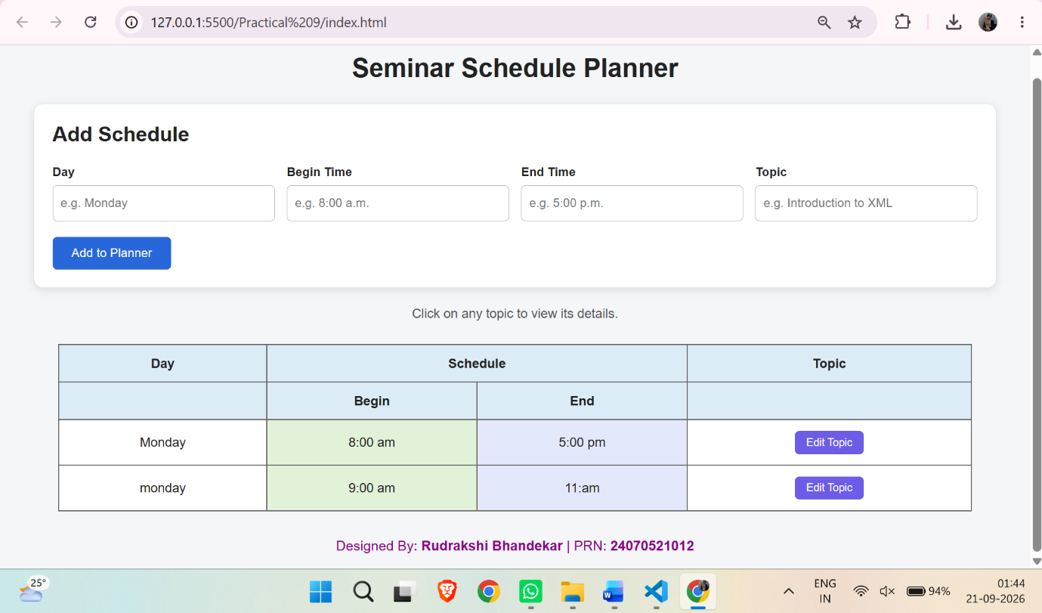
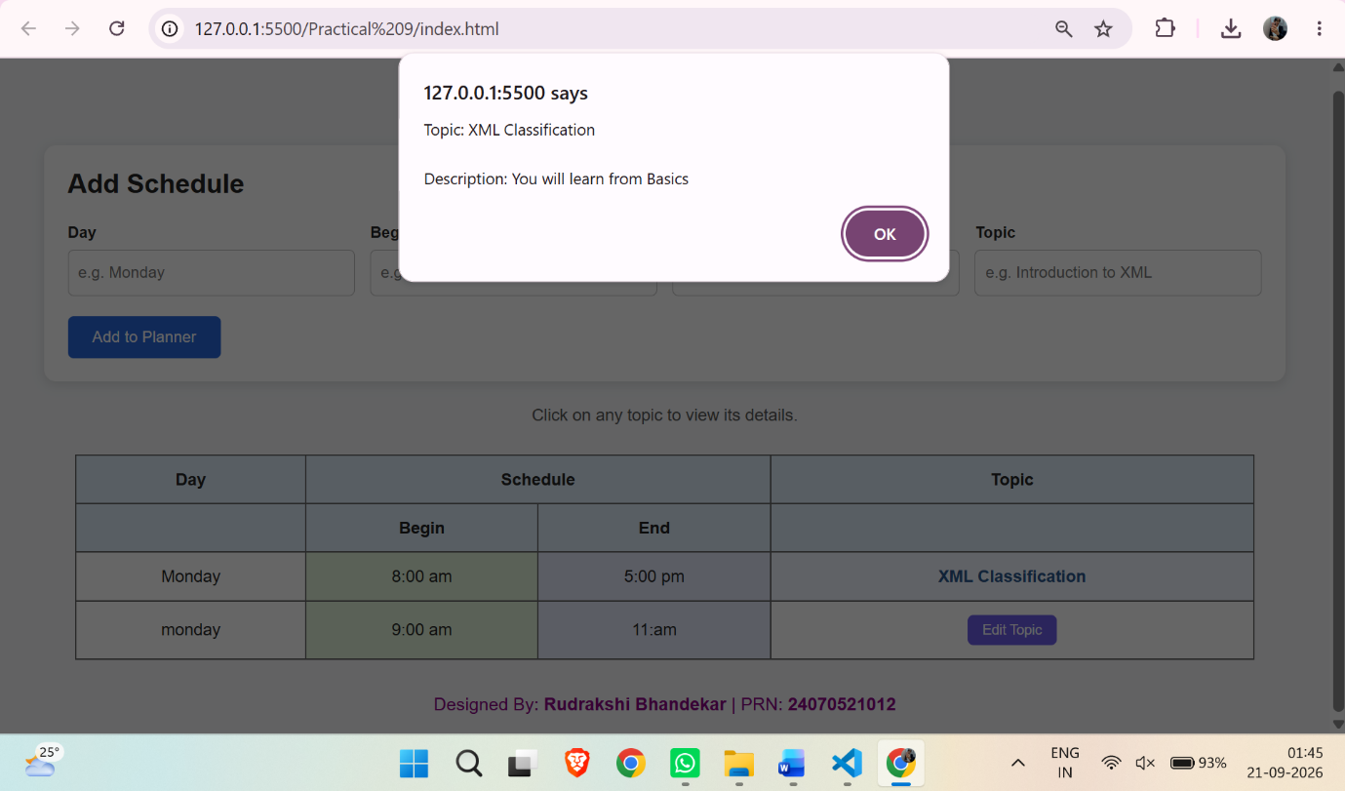
Conclusion –
The experiment successfully demonstrated web storage and JavaScript click events through theme preferences and a Schedule Planner.

